**Translating or editing labels on the form**

Most of the language of the form consists of either:

* If it is the question text on a Salesforce Custom Field, then the text is from the **Help Text** value on that field’s configuration. Changing the English-language text can be done by editing the Help Text on that field. Translating the value can be done through Salesforce’s [Translation Workbench](https://help.salesforce.com/articleView?id=workbench_overview.htm&type=5).
* A Salesforce Custom Label. These can be found by going to Setup and searching for Custom Labels. All of the labels in this application will start with the prefix “C501_”, and you should be able to find them easily by clicking the letter “C” above the list of labels.   
  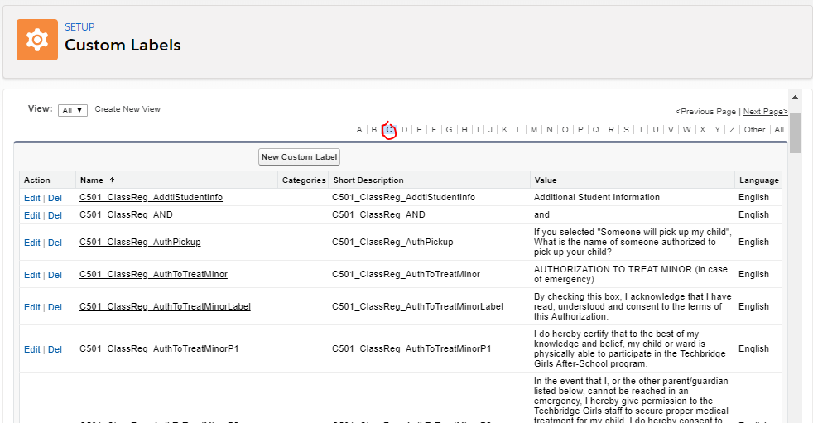  
  Change the English text by clicking on the label’s name and editing the **Value**. Translations can be added or edited in the translations list below.   
  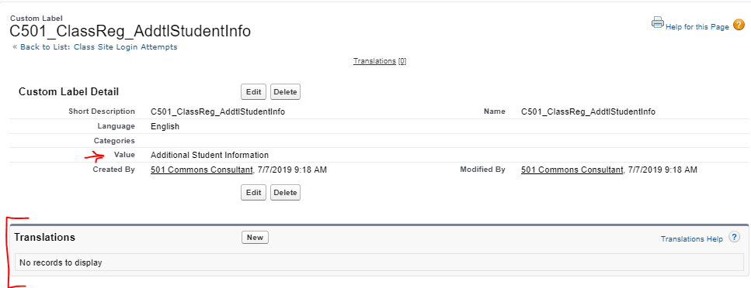

**Reviewing login attempts**

If you ever need to review attempts made by clients and other outsiders to log in to the form, review records of the **Class Site Login Attempt** object. These records will show you:

* The Email or Phone number used to receive the confirmation code.
* What their secret code was.
* The timestamp that the code was sent.

Records of this object older than a half hour can be deleted if reviewing them is not necessary, and no clients will be affected.

**How to add new fields to the form**

This form is built to allow Techbridge admins to add new fields to the form, should they want to. There are several steps necessary to make sure the field appears on the form and can be completed by the client.

*Considerations when creating your new field*

All fields that are displayed on the form as part of a field set are **required**. You should create your field in such a way that the client can always complete it. For example, if you are including a picklist asking “What is your favorite flavor of ice cream?”, you might think of only including “Chocolate”, “Vanilla”, and “Strawberry”, but to truly serve everyone you should also include negative answers (eg. “I don’t like ice cream”) and a catch-all (eg. “Some other flavor”).

*Set Help Text*

The question text that displayed on the form is the Help Text of your Salesforce field. Make sure that this is populated.

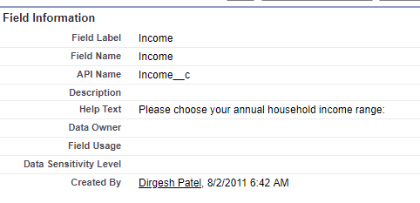

*Translate the field*

In order to serve clients who speak different languages, make sure to go to the Translation Workbench and translate the field, its Help Text, and if it is a picklist, it’s possible values. Information on Salesforce Translation Workbench can be found [here](https://help.salesforce.com/articleView?id=workbench_overview.htm&type=5).

*Add the field to a custom field set.*

Field sets are a way for you, the admin, to customize groups of fields to be used in other ways, such as on custom forms like this.

By default, the form loads the following field sets:

* **Contact:** C501_Class_Registration_Site_Child
* **Contact:** C501_Class_Registration_Site_Parent
* **Account:** C501_Class_Registration_Site_HH_Acct (at time of writing, this field set has no fields in it by default)

These field sets are part of the package that 501 Commons manages for Techbridge Girls, and will be overwritten when new versions of the form are deployed. To make sure your changes are not overwritten, you have the ability to create specifically-named custom field sets that override the ones that load by default.

Your API name of your custom field set must exactly match the name in this list:

* For fields on the Household Account record: C501_ClassReg_Site_HH_Acct_Custom
* For fields saved on the parent Contact record: C501_ClassReg_Site_Parent_Custom
* For fields saved on the child/student Contact record: C501_ClassReg_Site_Child_Custom

[Information on creating and editing fieldsets here.](https://help.salesforce.com/articleView?id=fields_editing_field_sets.htm&type=5)

After creating your field set, add all of the fields from the original field set that you want to remain on the form to your field set. Then, add your field to the field set.

*Give the site permission to use your field*

The form needs to be given specific permission to be able to see and write to the field you have added. Go to Setup > Sites and select “ClassRegistration”. Click the button “Public Access Settings”. Click “Object Settings”, then select the object your field is on. Click “Edit”, and then check the appropriate boxes to give the form both Read Access and Edit Access.

**How to remove fields from the form**

Fields that are inside field sets can be removed from the form. Fields that are not in field sets are hard-coded and cannot be removed without talking to a developer.

As with adding fields, a custom field set needs to be created to override the default one to remove a field from the form. Please follow the instructions above for creating a custom field set before continuing.

Once you have a custom field set with all the fields *you do not want to remove* populated, you are finished! All you have to do is just *not* have the field you don’t want in the field set.

**Preparing the form for a new term**

Before Techbridge begins accepting new students for a new term, some changes need to be made to the system to ensure that parents are able to register their children and receive the appropriate confirmation messages.

1. **Configuring schools:** Parents will be able to select the school that their child attends from a drop-down list on the registration form. All schools in the database will be listed. Make sure each school has:
   1. It’s correct **Region** properly selected.
   2. The **Next program start date** set. This is the date that classes will begin at this location.
   3. In the **Affiliated Contacts** list, the current teachers are listed with the **Role** “Teacher” and the **Status** “Current”, as in the screenshot below. Any previous teachers should have their status changed to “Former”.  
        
      